1. PROGRAM:

#include<stdio.h>

int main()

{

int c,f;

c=0;

printf("Celusis\t|\tFarhenheit\n ");

while (c <=100 )

{

f=(1.8*c) + 32;

printf("%d\t|\t%d\n",c,f);

c+=10;

}

return 0;

}

OUTPUT:

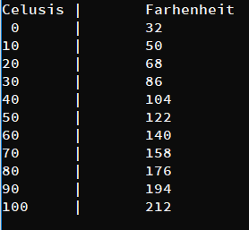

1. PROGRAM:

#include<stdio.h>

int main()

{

int n1=0,n2=1,n;

printf("Enter No of times :");

scanf("%d",&n);

printf("%d,%d,",n1,n2);

for(int i=3;i<=n;i++)

{

int temp=n1+n2;

n1=n2;

n2=temp;

if (i!=n)

{

printf("%d,",temp);

}

else

{

printf("%d",temp);

}

}

return 0;

}

OUTPUT:

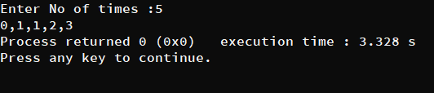

1. PROGRAM:

#include<stdio.h>

int main()

{

int n;

printf("Enter the integer: ");

scanf("%d",&n);

for(int i=2;i<n;i++)

{

if ((n%i)==0)

{

printf("%d\n",i);

}

}

return 0;

}

OUTPUT:

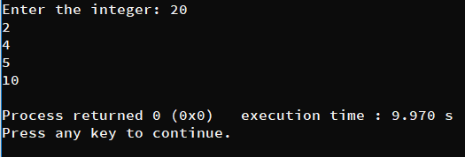

1. PROGRAM:

#include<stdio.h>

int main()

{

int num1,num2,i,gcd;

printf("Enter the Numbers : ");

scanf("%d %d",&num1,&num2);

for(i=1; i<=num1 && i<=num2 ;i++)

{

if(num1%i==0 && num2%i==0)

gcd=i;

}

printf("%d",gcd);

return 0;

}

OUTPUT:

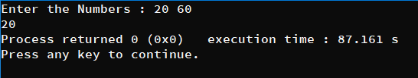

1. PROGRAM:

#include <stdio.h>

int main()

{

int n;

int p;

printf("Enter the integer: ");

scanf("%d",&n);

for (int i=2;i<n;i++)

{

p=0;

for(int j=2;j<i;j++)

{

if (i%j==0)

p=1;

}

if (p==0)

{

printf("%d\n",i);

}

}

return 0;

}

OUTPUT:

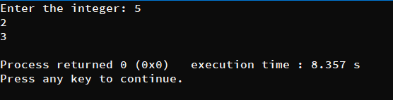

1. PROGRAM:

#include<stdio.h>

int main(void)

{ int start, end, flag1, flag2, j;

printf("Enter start: ");

scanf("%d", &start);

printf("Enter end: ");

scanf("%d", &end);

if(start<3)

start=3;

for(int i = start; i < end; i++)

{

flag1=0;

flag2=0;

for(j=2;j<i;j++)

{

if(i%j==0)

{

flag1=1; //number not prime

break;

}

}

for(j=2;j<i;j++)

{

if((i+2)%j==0)

{

flag2=1; //number not prime

break;

}

}

if(flag1==0 && flag2==0)

{

printf("{%d, %d}\n", i, i + 2);

i = i + 1;

}

}

return 0;

}

OUTPUT:

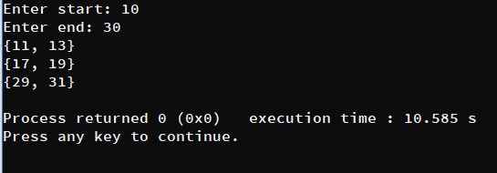

1. PROGRAM:

#include <stdio.h>

int main()

{

int n;

int rem, reverse=0;

printf("Enter Number: ");

scanf("%d",&n);

while (n!=0)

{

rem=n%10;

reverse = reverse*10 + rem;

n = n/10;

}

printf("Reversed Number : %d",reverse);

return 0;

}

OUTPUT:

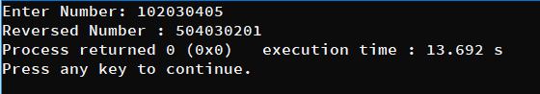

10.PROGRAM:

#include <stdio.h>

int main()

{

int no_of_tickets ,n=1;

int remain_tickets;

for (remain_tickets=100;remain_tickets>0;n++)

{

printf("Enter no of tickets: ");

scanf("%d",&no_of_tickets);

if (no_of_tickets>4)

{

printf("You should not exceed 4 tickets\n\n");

n -=1;

continue;

}

else

{

printf("You Have bought %d tickets\n",no_of_tickets);

remain_tickets = remain_tickets - no_of_tickets;

printf("Remaining %d are available\n",remain_tickets);

printf("Total number of buyers %d\n\n",n);

}

}

return 0;

}

OUTPUT:

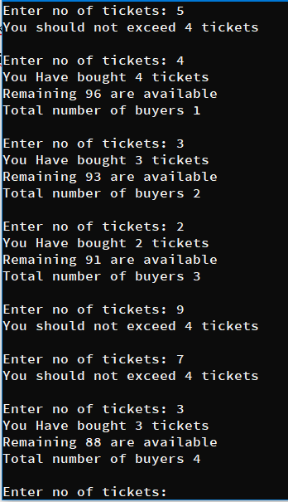

11.PROGRAM:

#include <stdio.h>

int main()

{

int a = 0, b = 0, c = 0, d = 0, e = 0, f = 0, g = 0, h = 0, i = 0, j = 0, n;

for (int k = 0; k <= 9; k++)

{

printf("Enter a number between 0 to 9 :");

scanf("%d", &n);

if (n >= 0 && n <= 9)

{

switch (n)

{

case 0:

a++;

break;

case 1:

b++;

break;

case 2:

c++;

break;

case 3:

d++;

break;

case 4:

e++;

break;

case 5:

f++;

break;

case 6:

g++;

break;

case 7:

h++;

break;

case 8:

i++;

break;

case 9:

j++;

break;

}

}

else

{

printf("Negative Number Exits Program!!\n");

break;

}

}

printf("No:of times 0's occured = %d\n", a);

printf("No:of times 1's occured = %d\n", b);

printf("No:of times 2's occured = %d\n", c);

printf("No:of times 3's occured = %d\n", d);

printf("No:of times 4's occured = %d\n", e);

printf("No:of times 5's occured = %d\n", f);

printf("No:of times 6's occured = %d\n", g);

printf("No:of times 7's occured = %d\n", h);

printf("No:of times 8's occured = %d\n", i);

printf("No:of times 9's occured = %d\n", j);

return 0;

}

OUTPUT: